GACE II -- Test Framework
MATHEMATICS
Early Childhood Education

Objective 0013 Understand processes and approaches for exploring mathematics and solving problems.

For example:
Objective 0013.1 focuses on identifying effective strategies (e.g., determining relevant information, simplifying, estimating) for solving single-step and multistep problems in mathematical and other contexts.

Authentic word problems involve student thinking. A workbook page with 20 2-digit by 2-digit multiplication problems followed by two word problems involving the same type of multiplication problem is not an authentic word problem. Without using mathematical thinking, the student could pick out the two digit numbers and multiply them, just as they did with the rest of the problems without words on the practice page.
Authentic word problems, both single-step and multi-step, involve following a problem solving method and selecting a problem solving strategy.

The most commonly used four step problem solving method, developed by George Polya, involves:
- Understanding the Problem
- Devising a Plan
- Carrying out the Plan
- Reflecting on the Problem

1. Understanding the Problem: Comprehension, Elements, and Strategies

Reading Comprehension

The first step in understanding the problem is reading comprehension. To ensure that students are able to read the problem, students need a working knowledge of the vocabulary and concepts involved in the question. This knowledge base, commonly referred to as mathematical conventions, is the foundation upon which mathematical thinking is built. For example, students need to know the meaning of mathematical terms and understand mathematical concepts to be able to understand the problem. A student with reading comprehension skills in other subjects may not necessarily transfer these skills to reading mathematical problems. Beyond word recognition, math specific vocabulary and concepts need to be developed so that reading comprehension of math problems will increase.

When students are taught to look for key words that they associate with certain operations, instead of focusing on the deep development of vocabulary and concepts, they are given shortcuts that many times inhibit understanding. Listing key words associated with certain operations as a method can also backfire when the same key word could be used for different operations.

For example, suppose a student was given the following problem, “Suzie bought five pieces of candy. Each piece cost $0.25. What was the total cost?”

A student with deep knowledge of vocabulary and concepts would be able to know what operation to use. Students with surface key word knowledge may have a hard time deciding if they should multiply or add because the word total could be used for either multiplication or addition.

Elements of Understanding

Understanding the problem also includes indentifying the question being posed. Students need to know what they are being asked to do. Students must also be able to indentify the information needed to solve the problem. They need to distinguish between information that is necessary and information that is extraneous to the solution. They also need to be able to identify any missing information.

Strategies for Enhancing Understanding

- Ensure prior knowledge of the “math conventions” including mathematical concepts and vocabulary addressed within the problem.
- Allow students to become familiar with the problem through visualization or re-enactment.
- Have the students rephrase the problem in their own words.
- Allow the students to explain why solving the problem is important.
- Ask if there is any information within the problem that is not needed for the solution.
- Have the students identify the information that they think is important within the problem.
- Make sure that the problem is realistic and relevant for the students.

2. Devising a Plan

Individually or in groups, discuss possible problem solving strategies. (Section 0013 B will detail specific problem solving strategies.) Have the students explain what strategy they would choose and why. Allow time for discussion of the possible strategies, including the pros and cons for each strategy chosen. Students should use their own ingenuity to devise a solution plan. Children should be encouraged to develop different ways to solve the problem. Whenever possible, allow the students to make estimations about the solution as part of the plan. This will encourage the students to think ahead as they begin with the end in mind.

- Carrying out the Plan

When implementing the plan, have students compare different approaches. There is no need to erase “mistakes” because realizing that a solution won’t work or an answer is going in the wrong direction is part of learning how to solve problems. New problem solving attempts can be compared to previous attempts in an effort to solve the problem. It is important for children to be able to select solution processes. Teachers can provide examples and encouragement, but the students should be able to think and solve problems for themselves. Have students record their thinking, problem solving sketches and computations along the way. A math journal is essential for documenting problem solving and thinking along the way. Teachers should also provide clues, if needed, as students work to solve the problems. Give the students an opportunity to share their solutions and explain their thinking. Teachers should ask questions about the reasonableness of student solutions and strategies. Open discussion without fear of failure can lead to increased student persistence in solving problems. Student persistence is a key factor in increasing problem solving ability.

- Reflect on the Problem
Reflecting on the problem involves looking back to see how the question was answered, looking forward to extend or modify a problem, and thinking about similar problems that could be solved with the same or a similar strategy. In looking back, students should reflect on the solution path that they chose and compare their solution with other valid solutions. In looking forward, students can change aspects of the problem and consider how the solution would have changed with different circumstances. Students can also extend the questions in light of the data obtained. Other problems can be posed and considered. Students can also see how other similar and relevant problems can be solved with the strategy they just developed. For example, the strategy for solving a problem on determining the height of a flag pole through equivalent fractions, heights, and shadows could also be used to determine the height of a tree. These applications increase the relevance and value of the problem solving process.

Objective 0013.2 focuses on demonstrating knowledge of strategies for investigating, developing, and evaluating mathematical arguments.

Students should develop their own problem solving strategies. The following strategies can be used to solve a variety of problems.

- Draw a Diagram
- Act it Out
- Look for a Pattern
- Make a Table or Chart
- Account Systematically for All Possibilities
- Solve a Simpler Problem
- Guess and Check
- Work Backward

- Draw a Diagram

Many problems can be well understood through a drawing or picture. When students make drawings or pictures to help them solve problems, they demonstrate that they are able to make representations out of written or spoken words. When students translate their mathematical thoughts into a diagram or picture, they are better able to “see” the math, both visually and spatially. The saying, “a picture is worth a thousand words,” aptly describes the depth of understanding that can be gained from a well constructed diagram or picture. Although this ability comes naturally to many, it can also be modeled and taught. Skills in drawing diagrams and pictures can be transferred to other content areas where spatial organization is also an important tool for understanding.

Here is an example:
After watching two basketball teams (with 5 players on each team) exchange handshakes after a game, Sheila wonders, “It looks like they just spread their germs. How many handshakes (opportunities to spread germs) were there?”
To solve this problem, draw a diagram of the two teams, with a symbol for each member of each team. Line up the two teams so that they are facing each other. Next, draw lines to represent the handshakes. As you can see, making this visual diagram can make the problem easier to solve.
When the students do a number of these problems, they may come to the realization that if they multiply the number on one team by the number on the other team they will come up with the number of handshakes. It is important to allow the students to make this discovery. If they do, it will be more meaningful and memorable for them.

- Act it Out

When students act out a problem, they are using physical representations to solve the problem. This hands-on method can be very effective with young children because it gets them physically involved in the problem. Many real world problems lend themselves to the use of this strategy. This strategy also has many applications outside of the classroom.

Here is an example:
Three friends decide to buy a new video game together. The video game costs $30, so each girl contributes $10. They send Sandy’s brother to the store to get the video game because he just got his license. He buys the video game, but since it was on sale, he receives $5 back in change. When he gets home, he has 5 dollars in his pocket. He gives Sandy and her two friends each a dollar back, and keeps the extra $2. (One dollar to each girl equals 3 dollars, and he pockets 2 dollars.) All three girls realize that they really only paid $9 each for the video game. They calculate that 9 X 3 = 27. Sandy’s brother pocketed $2. We know that 27 + 2 = 29. What happened to the extra dollar, they gave him $30 to begin with?

Are you wondering what happened to the extra dollar? Take some time to think about the problem before reading about the solution.

Try acting this problem out. Notice that the order of the operations involving multiplication, division, addition, and/or subtraction changes when the transactions are done in reverse. It is customary to do all the multiplication and division first, and then all the addition and subtraction. The problem demonstrates the importance of doing calculations in the correct order. Although multiplication and division are always done first, in this problem, they must be done after the subtraction because the problem must be done in reverse.

If he would have subtracted 3 dollars from the total of 30 when he gave them their money back, he would have had 27 dollars left to account for. So the video game really cost 25 dollars. Then he can pocket 2 dollars, because 27 – 2 = 25. In this way, all the money is accounted for and there is no missing dollar. However, if the rules involving the order of operations are not followed in reverse order, such as subtracting three dollars and then multiplying 9 X 3 = 27 before subtracting the two dollars he pocketed, then it appears that there is a missing dollar. The lesson to be learned is once you start subtracting, go ahead and do all the adding and subtracting at once and then do all the multiplying and dividing at once.

- Look for a Pattern

Students can have fun looking for patterns. They can find patterns in nature, people, shapes, and numbers. Developing their ability to recognize and predict patterns will enable them to solve problems with this same strategy. For example, students can learn to recognize patterns in blocks that can translate into recognizing odd and even numbers. Block patterns of 1, 4, 9, 16, and 25 blocks can translate into recognizing the concept of square numbers. When solving problems, students can draw on their knowledge of patterns to predict the future.

One famous pattern can be seen the Fibonacci sequence. Begin with 0, 1. Add these two digits to get the third number in the sequence, 1. Then add the last two numbers, 1 + 1, to get the fourth number in the sequence, 2. Continue the same procedure to generate more numbers in the sequence. This pattern can be seen in nature.
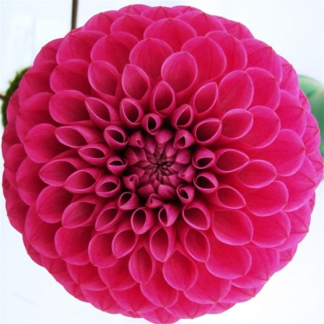
Image reference:
http://frarys-fresh-flowers.blog.co.uk/2009/09/22/compositae-chrysanthemums-dahlias-7017567/
Count consecutive rows of this chrysanthemum. You will notice that they are all consecutive numbers in the Fibonacci sequence. This knowledge can be used to solve problems. In art, a missing part of a picture of a pineapple, flower, or plant can be reconstructed with the pattern found in the sequence.

4/5. Make a Table or Chart/ Account Systematically for All Possibilities

Making a Table or Chart is an effective problem solving strategy for organizing information. It can also be used to account systematically for all possibilities. For example, suppose the following problem:

Jenny and Keith traveled to Peru to help out on a farm. The farmer raised both lamas and emus. Looking under the fence, they counted 26 legs. They could not tell the lama legs from the emu legs. Jenny and Keith had never seen lamas or emus before, but they knew that lamas have four legs and emus have two legs. The farmer told them that he had 9 animals. How many lamas did the farmer have? How many emus did the farmer have?

The students can construct a chart to find the answer:

Emus | Lamas | Total Animals | Emu Legs | Lama Legs | Total Legs
1 | 8 | 9 | 1 x 2 = 2 | 8 x 4 = 32 | 34
2 | 7 | 9 | 2 x 2 = 4 | 7 x 4 = 28 | 32
3 | 6 | 9 | 3 x 2 = 6 | 6 x 4 = 24 | 30
4 | 5 | 9 | 4 x 2 = 8 | 5 x 4 = 20 | 28
5 | 4 | 9 | 5 x 2 = 10 | 4 x 4 = 16 | 26
6 | 3 | 9 | 6 x 2 = 12 | 3 x 4 = 12 | 24
7 | 2 | 9 | 7 x 2 = 14 | 2 x 4 = 8 | 22
8 | 1 | 9 | 8 x 2 = 16 | 1 x 4 = 4 | 20

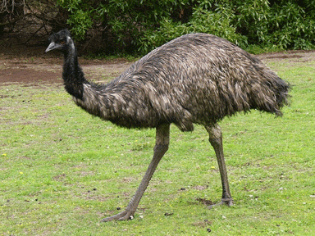
Citation for graphic: http://briggs-country-farms.wikispaces.com/file/view/emu1.gif/138314783/emu1.gif

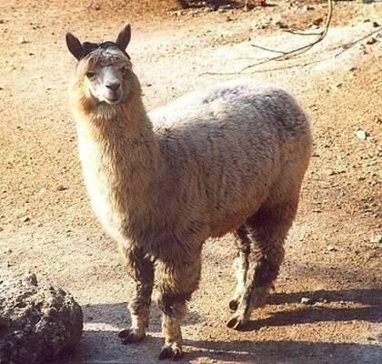
Citation for graphic: http://dic.academic.ru/pictures/dewiki/97/alpaka_33444.jpg
This lama/emu problem can also be solved by drawing a diagram.

6/7. Solve a Simpler Problem and Guess and Check

Two problems that have been traditionally solved with guess and check are the magic square and the balanced triangle.

The Magic Square

In the magic square, there is a 9 x 9 square with 9 empty boxes. Students are asked to fill in each of the squares with the digits 1 – 9 so that all the rows, columns and diagonals add up to the sum of 15. Try to solve the magic square using “Guess and Check.” If the problem is too hard, try to solve the balanced triangle first.

The Balanced Triangle

There are 6 empty circles in the balanced triangle. The students are to fill in the empty circles with the digits 1 - 6 so that each of the three numbers on every side of the triangle can be added to obtain a sum of 12. Students can use “Guess and Check” to try out the numbers in the slots and attempt to make them fit together to generate the required sum.

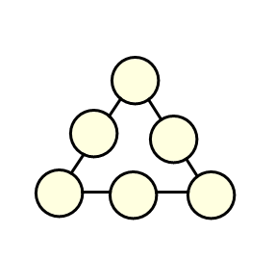

Accounting systematically for all possibilities can also be used to solve the Magic Square and the Balanced Triangle.

For the Balanced Triangle, try making a chart with all the combinations of three numbers that when added give you the sum of 12. Notice the numbers that appear on the chart more than once. These numbers will be your vertices (corners) on your triangle. The other numbers will be between those vertices.

For the Magic Square, try making a chart with all the combinations of three numbers that when added give you the sum of 15. First make sure that you do not have any duplicates. Next, notice the number that appears on the list four times. That number will be in the middle square because it will be used four times. The numbers that appear on the list three times will be in the corners because they will be used in three of the number sentences. The remaining numbers will only be used twice so they will be between the corner numbers on the edges. In a process of elimination, referring back to your original list of combinations, place the numbers purposefully to solve the problem.

Solving a simpler problem is also a useful strategy for equivalent fractions. For example, if students are asked to solve equivalent fractions with complicated numerators and denominators, providing a simpler problem with frequently used numerators and denominators that can be easily visualized can make the concepts easier to understand. As the students apply the concepts to simpler problems, they build the knowledge they will need to solve more complicated problems.

- Work Backward

The problem solving strategy of working backward begins with the concept of inverse operations. Addition and subtraction are inverse operations. Multiplication and division are inverse operations. With this knowledge in mind, students can solve a variety of problems where they need to retrace their steps.

For example, Christina gave half of her money to World Vision to purchase chickens for needy families. Then, she noticed that her sister Marianna needed some new play clothes so she spent $12 to buy her a new pair of shorts. While they were at the mall, they went out to eat and Christina paid $20 for their meal. When she came home, her mother reimbursed her $12 for the play clothes she bought for her sister, Marianna. In the end, she had $17. How much money did she have to begin with?

To solve this problem, students start at the end and retrace Christina’s transactions. So, they begin with $17. Then they subtract the $12 that Christina was reimbursed and get $5. Then they do the opposite of paying $20 for the meal and add $20 to get $25. Next they do the opposite of subtracting $12 for the shorts and add $12 to get $37. Since she gave half her money to World Vision, she was really dividing by 2, so they will do the opposite and multiply $37 X 2 to get the original amount of money that she started with, $74.

Objective 0013.3 focuses on demonstrating knowledge of how the language and vocabulary of mathematics are used to communicate ideas precisely.

It is important to know the foundational vocabulary and to be able to communicate effectively about math. There are many websites with this kind of information for reference. While teaching, have the students create a glossary of terms that they can refer back to. It is important to teach vocabulary for every math concept as that concept is being processed. As this review guide goes through each objective, the related vocabulary will be defined in context rather than as a list of terms to be studied.

Objective 0013.4 focuses on demonstrating knowledge of selecting, applying, and translating among a variety of materials, models, and methods, and of technologies used to explore mathematical concepts and solve problems.

Elementary grades mathematics teachers have a wealth of materials, models, and methods that can assist students in understanding concepts.

Base 10 Blocks:

These need to be available at all times for the introduction of new concepts. They are used primarily to demonstrate the base 10 number system with ones, tens, hundreds, and thousands. As students learn each new aspect of place value, they will need these visual representations to explore relationships. They can trade 10 ones for a ten stick and then ten “ten sticks” for a hundred flat. They then exchange ten hundred flats for a “thousand cube.” These blocks have corresponding graphics that can be used as mats for students to work on. Computer graphics on interactive whiteboards can also be used to generate pictures of the models and interactive work spaces. The mats have columns for each place value.

As students progress in their understanding, base ten blocks can also be used to demonstrate decimal concepts. The hundreds flat would take on the value of one whole. With this new understanding, the graphics can then be used so that the “ten stick” would really represent one “tenth” and the unit cube would represent one “hundredth.” Graphics such as this can be found in materials associated with decimals and place value less than 1.
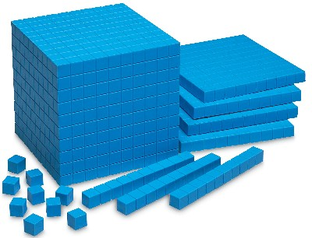

http://www.innovativeed.com/images/0924_0926.jpg

The National Library of Virtual Manipulatives has interactive base 10 blocks that can be used for addition, subtraction, regrouping, and decimals. All the activities from the site are available at the following website:

http://nlvm.usu.edu/en/nav/category_g_2_t_1.html

Pattern Blocks:

These are polygon shapes that can be used for geometry, patterns, and fractions. Students can create shapes with the blocks and analyze angles and patterns. Task cards are available as students learn about how to arrange the shapes. Students put the corners together and count the number of shapes around a given center point. They study the angle measurements of each shape. They also can use the pattern blocks to learn about fractions. Three triangles make up the trapezoid and two trapezoids make up the hexagon. As these blocks are placed in order, patterns can be made and recognized.

A digital applet for using pattern blocks on the computer and/or interactive whiteboard can be found at the National Council of Teachers of Mathematics Illuminations website.

http://illuminations.nctm.org/activitydetail.aspx?id=27
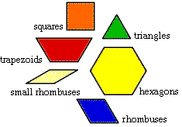

Citation for graphic: http://mathforum.org/sum95/suzanne/pattern.blocks.gif

Liquid Measure Fractions:

Liquid Measure Fractions is a gallon model with embedded layers. The smallest cube holds one cup of water or rice. Two cup measures fit inside a green pint measure. Two green pint measures fit inside an orange quart measure. Two quarts fit inside the blue half gallon and two half gallon units fit inside a red gallon. These are useful in teaching customary liquid measurement units because the parts can be identified in relation to the whole. Research on how the brain works emphasizes the importance of part to whole learning.

Students can experiment with these models. They can make comparisons among units. They can also identify the containers used in everyday life in relation to this part-to-whole model to make connections and construct meaning. Fraction concepts and equivalent fractions can be modeled with these containers. Students can use the models to make conversions within liquid measurement units. For example, they can use the model to determine how many cups are in a quart or how many pints are in a gallon, etc.

Students can also use Liquid Measure Fractions to learn about density. They can take several yellow cup units and fill them with water, rice, beans, or popcorn. On a balance scale, they can determine the mass of each cup. After subtracting the mass of the container, they can calculate the density of the water, rice, beans, or popcorn by using the Mass divided by Volume formula. Volume is equal to length X width X height. They can then determine if the material will sink or float with the knowledge that water has a density of 1. If the material is less dense that one, it will sink. If the material has a density that is more than 1, it will float.

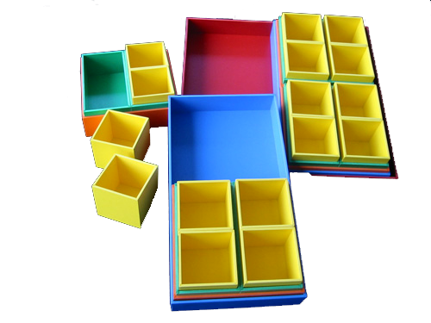

Attribute Blocks:

Attribute blocks come in three colors, two sizes, two thicknesses, and five shapes. They can be used to sort and classify according to the attributes for each piece. For example, a teacher may choose to have the students sort by thickness (thick or thin), color (red, blue or yellow), shape (circle, hexagon, square, rectangle, or triangle) or size (large or small).

As the students progress, they can use attribute hoops to sort more than one attribute at a time. For example, one hoop can be for yellow shapes and another hoop can be for circles. When the attribute hoops overlap, a Venn diagram is created. In the intersection of the two hoops, one would place a yellow circle that would include all large and small, thick and thin yellow circles. Another overlapping circle could be added with a different attribute. If the next attribute is “thick” all thick yellow circles would be in the intersection of all three hoops.

The students can also use these same blocks to generate and recognize patterns. The teacher can begin a pattern and then ask the students if they know what object will come next. Instead of stating the rule, the student will supply the next one in the pattern to demonstrate knowledge of the rule. The class can continue in this way until all the students have been able to figure out the rule and apply it to the next item in the sequence. With this strategy, each student would have an opportunity to think about the rule and select the next item in the sequence.
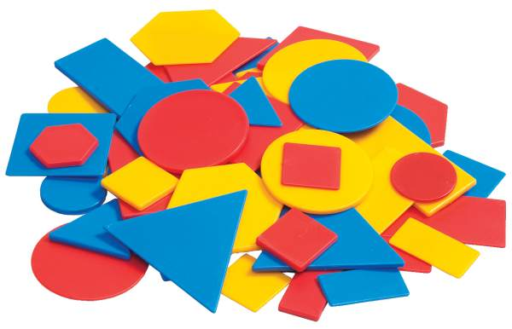
Image citation: http://rainbowresource.com/products/042604.jpg

An applet with interactive computer activities on attribute blocks can be found at the National Library for Virtual Manipulatives. Interactive whiteboard software also has activities that can be created involving attribute blocks.

http://nlvm.usu.edu/en/nav/category_g_2_t_3.html

Unifix Cubes:

Unifix cubes link on the top and bottom. They can be used for addition and subtraction concepts as well as measurement units. Unifix cubes can be used to teach patterns in color. They also work well when teaching about simple place value such as “ones” and “tens”. Students can make “tens” and then separate them when they need to regroup for subtraction.

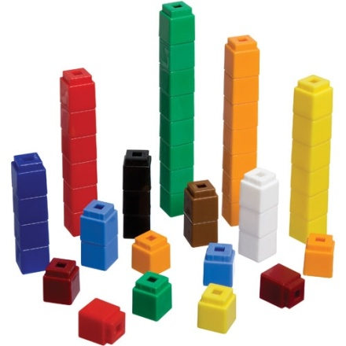

Image citation: http://childcare.scholarschoice.ca/images/products/25/Unifix-Cubes-100-Each-Of-10-Colours-N5140_XL.jpg

Rainbow Number Puzzles:

For early learners, these puzzles can serve as a visual representation of the concepts of number. For example, the zero puzzle does not have a piece. The one puzzle has one piece; the two puzzle has two pieces, etc. With these materials to play with, students will reinforce concepts of number and counting as they put the puzzles together. On the back of each piece, a symbol for that number helps the children to remember the puzzle that the piece belongs to. There is a handprint on the back of every 5 piece. There is an eye on the back of the number two puzzle pieces.

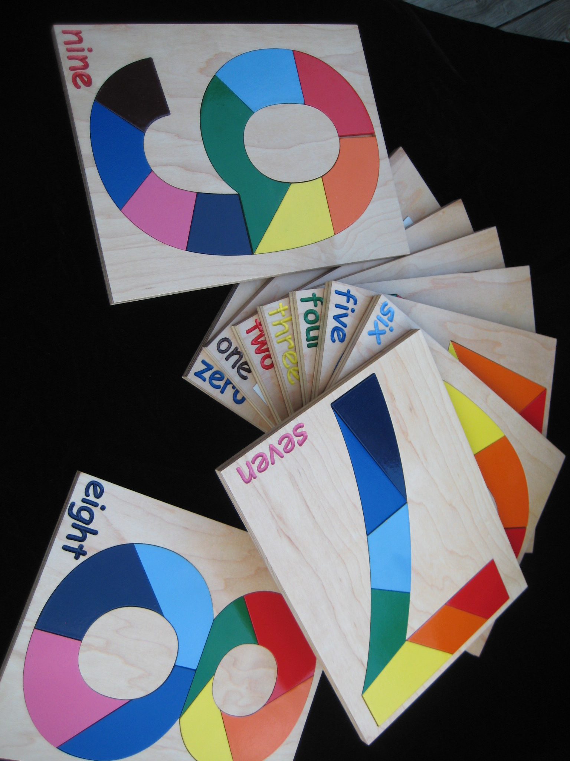

STAR 10 Cards:

For the development of numeracy, these are regular playing cards with four different types of numbers from zero to nine, including ten frames, rainbow numbers (as described above), tally marks, and dot cards. Students can play traditional games such a Memory, Go Fish, and War with these cards as they learn to compare and order numbers, add, and count. There is an “Odd Man Out” card that can be used when playing the traditional “Old Maid” game. With these games, students will develop number sense as they see each number in more than one way. They will also develop flexibility of thinking about numbers.

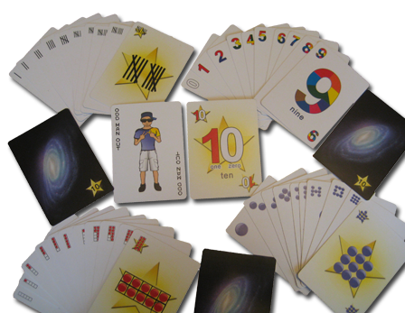

Multi-Link cubes:

Multi-Link cubes can attach to other Multi-Link cubes on all 6 sides. They are useful when teaching about perimeter, area, and volume. They have all the functionality of Unifix cubes, but they are flexible enough to be used for other concepts such as multiplication and division. Students can also use them to learn about square numbers. They can make a 3 X 3 square with these cubes and then be able to count the number of cubes needed, 9, discovering the concept of a square number as the number of cubes necessary to make a certain length, in this case 3, into a square, in this case 9. They can also create arrays to represent multiplication and the inverse of multiplication, division. These cubes can also be used as students learn about fractions. They can create arrays of different numbers with different colors to represent fractions.

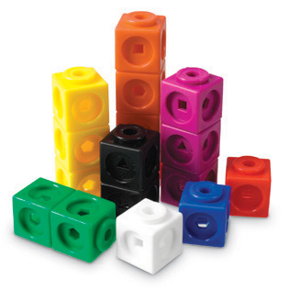
Image citation: http://www.learningstore.com.sg/images/p4285.jpg

Geoboards:

Geoboards are pegboards that come with rubber bands. These are useful as students create geometric shapes such as triangles, squares, rectangles, etc. Some concepts related to geoboards include angles, similar and congruent, and types of polygons. For example, a teacher could have the students each create their own triangle. The students would then group themselves into categories of similar triangles. Some students may have made right, isosceles, or scalene triangles. A whole group discussion of the similarities and differences in the triangles can lead the students to discover the properties of triangles. A similar activity could be done with different types of quadrilaterals.

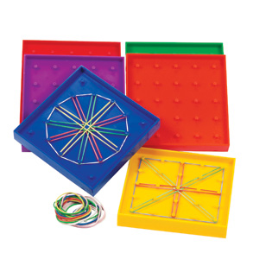
Image citation:
http://images.learningresources.com/images/products/en_us/detail/prod0425_dt.jpg

Quadrilateral Pieces:

Quadrilateral Pieces is a Geometry Puzzle that can be used to give students experience in solving puzzles with right, acute, and obtuse angles. Each quadrilateral piece is a quadrilateral (four sided figure). Each piece consists of four angles, one acute angle, one obtuse angle, and two right angles. Four of these pieces can be used for constructing quadrilaterals such as trapezoids, rectangles, squares and parallelograms. Similar to pattern blocks, they can also be used for design. Students can make designs and then direct other students to make similar designs through verbal cues rather than visual cues. Students can practice geometry related vocabulary such as right angles, acute angles, obtuse angles, parallel, and perpendicular as they direct other students to make specific designs with the quadrilateral pieces. Concepts of symmetry and rotation can also be applied to lessons involving the quadrilateral pieces.

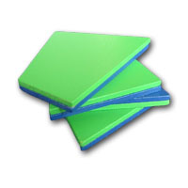

Objective 0013.5 focuses on demonstrating knowledge of the interconnections among mathematical concepts.

According to the National Council of Teachers of Mathematics, the mathematics content standards need to be taught in an integrated manner. Measurement, data analysis, and geometric concepts can be integrated with number and operations concepts. For example, if a lesson involves measuring, the students can also use concepts of number as they add if using linear measurement or multiply for area and volume. The liquid measure fractions model connects measurement concepts such as cups, pints and quarts with concepts of number such as adding and multiplying fractions.
In data analysis, students use geometry to make visual representations of data and concepts of number to graph results. In geometry, students also make use of concepts of number and measurement as they learn about polygons, perimeter, and area. The Quadrilateral Pieces take concepts of geometry such as angles and symmetry and combines them with problem solving for effective learning. All the seemingly distinct aspects of mathematics can be integrated and connected. In this way, learning is constantly reviewed and reinforced. Connections serve to make each distinct area of mathematics more relevant and meaningful.

Objective 0013.6 focuses on recognizing applications of mathematics in other content areas and in everyday life.

Mathematics only makes sense if it is taught within the context of problem solving. Situations that involve problem solving can be derived from other content areas such as science or social studies. The expression of mathematics within these content areas can serve to bring meaning to the other content areas as well as relevance to the study of mathematics. Taught in isolation, many mathematics concepts can be meaningless without a proper context or reason to use the mathematics to be studied. These connections to other subjects can be made with art and measurement, social studies with data analysis, or science with graphing and geometry. Math can be interwoven into literature through the use of trade books.

Test Example –

Answer:

Vocabulary Words to Consider –

For Further Study –

Practice Questions –

0013.1

0013.2

0013.3

0013.4

0013.5

0013.6

Annotated Answers to Practice Questions –

0013.1

0013.2

0013.3

0013.4

0013.5

0013.6

Objective 0014 Understand concepts and skills related to numbers and mathematical operations.

For example:

Objective 0014.1 focuses on applying concepts of quantities, numbers, and numeration to compare, order, estimate, and round.

There are stages of development as students are introduced to concepts of number. Pre-number concepts include one-to-one correspondence and classification. Unifix cubes and attribute blocks are useful in developing these concepts through matching and sorting activities. Other household items can be used to reinforce these concepts. When setting the table, early learners can recognize the one to one correspondence when every plate needs exactly one glass and one fork.

The stages of learning how to count include knowing the names of the numbers in order, using one to one correspondence to match each consecutive number name with an object, counting each object only once, recognizing the number symbol for each digit and knowing that the last number counted names how many.

The rainbow number puzzles are helpful because they allow the students to count within the number symbol. Without this type of visual representation, the symbol for a number can be an abstraction just as the value of “x” or “y” can be an abstraction for older learners. When developing number sense in early learners, ten frames provide the structure needed for visual recognition. An empty ten frame has two rows of five boxes each. As the dots are filled in within the boxes in consecutive order, the students see the dots in relation to the whole, 10. Five frames use the same concept but contain only one row with five boxes.

Dot cards are also useful in developing numeracy. Similar to dots on dice, students should develop the ability to recognize the number of dots without counting them. The dots should not always be in the same configuration. Different configurations for the dots will help the students to develop flexibility of thinking when recognizing numbers. Tally marks are another way the students can learn to keep track of numbers when counting. Tally marks are useful because they assist the students in seeing groups of five numbers and counting by fives.

After the students learn to count and then count backwards from 10 down, the students should begin to practice skip counting. Counting by twos, threes, fours, and fives can be done with a hundreds chart as a visual aid. Students can use interactive whiteboard software to highlight the numbers as they skip count. They can generate patterns that can help them locate numbers within the hundreds chart. As they learn about the geography of the numbers within the hundreds chart, they can recognize one more, one less, ten more, ten less, etc. by referring to the visuals.

Concepts of rounding can be taught with base 10 blocks. As students represent a given number, for example 24, they will select two tens sticks and four ones blocks. Next, tell the students that they need to find the number closest to 24 but they cannot use any ones blocks. Using problem solving, the students will be able to recognize that giving up four blocks makes less of a difference than increasing the number of blocks by six to have 3 ten sticks instead of 2. In this manner, rounding is introduced through problem solving. Any concept discovered through problem solving is more likely to be stored in long term memory.
The same process can be used when rounding to hundreds or thousands.

In teaching the students about comparing and ordering numbers, begin by using manipulatives such as base 10 blocks. Other household items can be effective teaching tools for comparing and ordering numbers. For example, students can use beans to count. They can make their own ten sticks and hundreds flats by gluing 10 beans onto each wooden Popsicle stick and then putting ten sticks together to made a hundred flat. With classroom or student created manipulatives, students can compare and order any given set of numbers.

Students should also be encouraged to play simple games with numbers to develop fluency. STAR 10 cards, incorporating the Rainbow Numbers, Tally Marks, Ten Frames, and Dot Cards can be used to reinforce concepts through constant exposure to various representations. With the STAR 10 cards, students can play WAR as they compare numbers at every step. They can also play matching MEMORY games as they put all the cards face down and turn over two at a time until they get a matching pair of numbers. GO FISH and ODD MAN OUT can be played so that students have an opportunity to practice comparing, ordering and matching numbers.

Objective 0014.2 focuses on demonstrating knowledge of the concepts of place value, prime numbers, multiples, and factors.

Place value is a representative concept. Base 10 blocks and student created models are effective tools for teaching place value. As the students collect ten items, they can trade them in for a ten stick. Ten sticks can be traded in for a hundred flat. Ten hundreds flats can be traded in for a thousand cube. Place value games such as “Fair Trade” can be used to demonstrate the concept of place value. Students learn about ones, tens and hundreds. They can apply that foundational learning to the next period in place value, thousand, ten thousand, and hundred thousand. As they move on to the next period, million, ten million, and hundred million, point out that the ones, tens and hundreds are repeated for each set of three numbers with higher denominations of numbers. Commas are used to separate the periods.

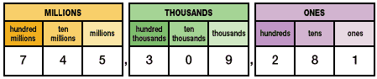
Citation for graphic: http://www.eduplace.com/math/mw/background/4/01/graphics/ts_4_1_wi-2.gif

Multiples can be explored through skip counting and graphed on a hundreds chart. Multiples are associated with multiplication facts. Repeatedly adding the same number will also generate multiples of that number. For example, the multiples of 3 are 3, 6, 9, 12, 15, 18, 21, etc. Factors of any given number are numbers that when multiplied together will result in the given number. For example, the factors of 24 are 1, 24, 2, 12, 4, 6, 3, and 3. The only factors of prime numbers are one and the prime number itself. For example, 5, 7, 13, and 19 are all prime numbers. Composite numbers are whole numbers that are not prime numbers.

To teach about multiples and prime numbers, one can use interactive whiteboard software to create Venn Diagrams. The circles can be labeled for specific numbers. As students go through the counting numbers, they can include them on the chart.

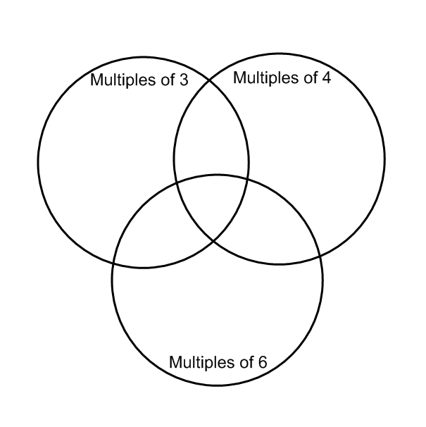
When using a diagram such as the one above, students practice identifying common multiples and placing them in the overlapping sections on the chart. If they go through the counting numbers, they will notice that the prime numbers will not be found on the inside of the chart very often.

When teaching students about factors, base 10 blocks can also be used. If the students begin with 24 ones blocks, ask them to line up their blocks in even rows and columns. When doing so, they might have 2 rows with 12 blocks in each, 3 rows with 8 blocks in each, 4 rows with 6 blocks in each or one row with 24 blocks. As they generate these solutions, have them record their numbers of rows and columns. This will introduce them to the concept of factors. Comparing models, they should then list all the possible factors of 24 by looking at the number of columns and rows for each solution.

Objective 0014.3 focuses on recognizing equivalent forms of common fractions, decimal fractions, and percentages.

Equivalent fractions can be taught using models such as rectangles. For example, begin with several rectangles that are the same size. Divide one rectangle into two equivalent sections and a second rectangle into four equivalent sections, then eight and sixteen sections. The visual models below can be used to reinforce equivalent fraction concepts. 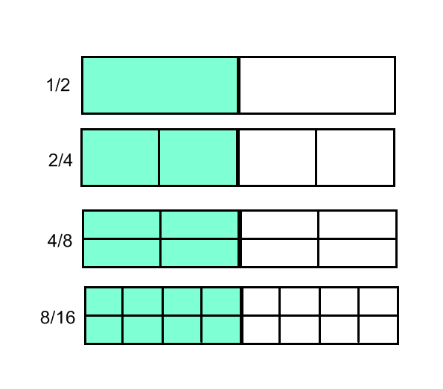
Base 10 blocks can also serve as models for decimal fractions. Decimals are fractions with a denominator that is ten or a multiple of ten. Decimals are all numbers that are less than one. When transitioning the base 10 blocks to represent decimals, the hundreds flat would represent one instead of a hundred. In this way, each stick would become a tenth instead of a ten and each cube would represent a hundredth instead of one. A chart such as the one below can put all the information into perspective in relation to the entire number system.

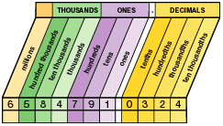

http://www.eduplace.com/math/mw/background/6/01/graphics/ts_6_1_int1-1.gif

Percentages can be taught in relation to fractions and decimals. Fractions have a numerator (number of selected parts) and a denominator (number of parts in the whole). With decimals, the denominator is always ten or a multiple of ten. With percentages, one whole is equivalent to 100%. Fractions with a denominator of 100 can be easily converted to percentages by eliminating the denominator and including the percent sign. Decimals expressed to the “hundredths” place can also be easily converted to percentages by removing the decimal and including the percent sign.

For example:

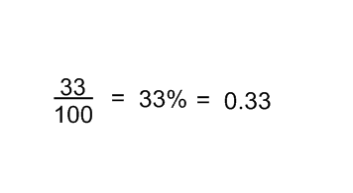

Objective 0014.4 focuses on applying knowledge of the relationships among mathematical operations and strategies for using the basic four operations with variables and numbers.

Instruction in the four basic operations begins with addition concepts. Adding one, two and three digit numbers begins with manipulatives. Students learn to put the numbers together. Vocabulary related to addition including sum, addend, and total along with symbols such as the equal sign are introduced with the actual items being added together. When there are ten of an object, ten is then counted as one in the tens column. When there are ten tens, they are counted as one hundred, and so forth. Strategies for teaching adding include one more, two more, doubles, near doubles, and counting on.
The inverse operation for addition is subtraction. There are three types of subtraction problems:

(1) How many are left?
(2) Comparison
(3) How many more?

In a “How many are left?” problem, the student begins with a certain quantity. Some are taken away and the students are to determine how many are left. In a comparison problem, there are two quantities and the student is to determine the difference between the two quantities. In a “How many more?” problem, the students have a certain quantity, but need more to get the desired quantity. This type of subtraction problem takes the difference between the number needed and the current number. Some strategies for subtraction include counting on and counting back.

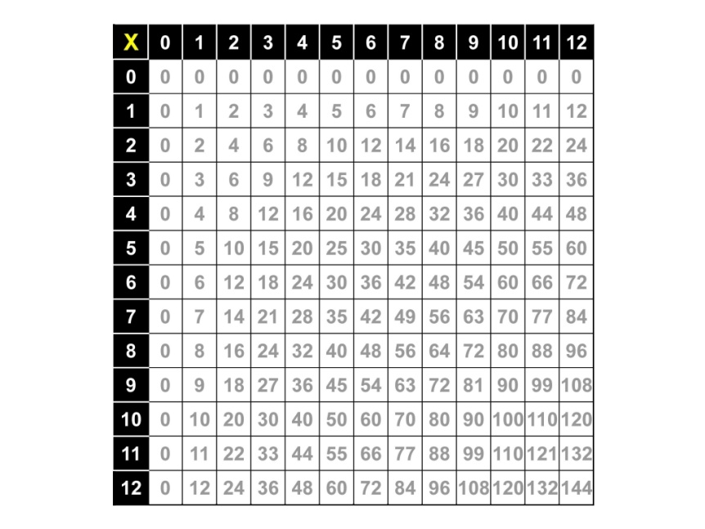

Image citation:
http://swansmath3-4.wikispaces.com/file/view/multiplication_table_complete.jpg/56588252/multiplication_table_complete.jpg

Division is the inverse of multiplication just as subtraction is the inverse of addition. As students focus on fact families, they will note the relationship between multiplication and division.

Objective 0014.5 focuses on demonstrating knowledge of properties of numbers and the number system (i.e., commutative, associative, distributive, identity, and property of zero)

The commutative property applies to both addition and multiplication. When numbers are added the order of the numbers can be reversed and the result will still be the same. When two numbers are multiplied, they can be multiplied in any order. The commutative property does not apply to subtraction or division. For example: 5 X 4 = 4 X 5 and 3 + 2 = 2 + 3.

The associative property also applies to both addition and multiplication. If there are three numbers to be added or three numbers to be multiplied, the order does not matter. For example: 3 + (4 + 5) = (3 + 4) + 5 and 2 X (3 X 4) = (2 X 3) X 4

The distributive property involves taking a number multiplied by terms inside parentheses (term) and distributing it to each term within the parentheses. Terms within the parentheses are separated by a plus sign or a minus sign. For example: 3X (2 + 4), sometimes written with the multiplication understood as 3(2+4), really means (3 X 2) + (3 X 4). With these simple numbers, one can see that the two expressions are equivalent. In this way, the three is multiplied by each term within the parentheses.

The identity for addition is plus zero. This means that zero added to any number will be equal to that same number. For example: 5 + 0 = 5. Zero is the identity for addition. Adding zero to any number will not change that number.

The identity for multiplication is one. This means that any number multiplied by 1 will be equal to that same number. For example: 5 X 1 = 5. One is the identity for multiplication. Multiplying any number by one will not change that number.
When dividing, there can be a zero in the numerator, but not in the denominator. This is because you can have zero pieces of something (really no pieces at all), but you cannot have a number of something and put them in groups of zero. You cannot divide them into zero pieces. This is why zero can be in the numerator, but not the denominator.

For example: 0/3 is acceptable but 3/0 is not acceptable because it is impossible to divide any number by zero.

Objective 0014.6 focuses on performing calculations with whole numbers, decimals, and fractions.

The process of computations involves algorithms. Algorithms are methods for computing. These algorithms are built upon a foundation of learning. Place value, basic facts and math properties are all needed to successfully compute.

Here is a graphic to illustrate these conceptual building blocks:

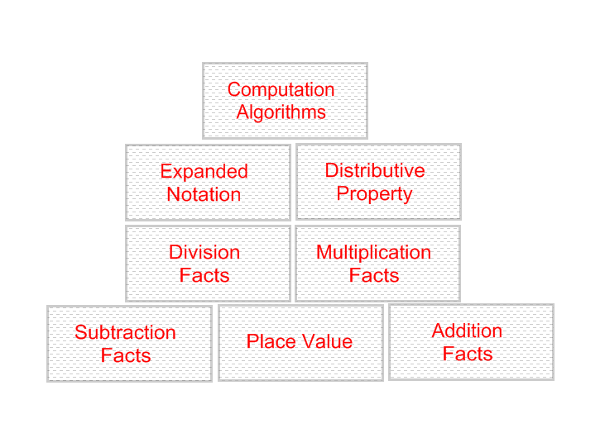

When adding whole numbers, students need to be able to line up the columns so that the ones are added to the ones and the tens are added to the tens, etc. They also need to be able to make tens and “carry” the tens to the next column. Notice that the “ones” column is highlighted in yellow and the “tens” column is highlighted in green. Students should use models such as unifix cubes or base ten blocks when learning these methods for adding.

Since subtraction is the opposite or inverse of addition, these methods can be taught together. Notice that the students should start by looking at the ones column to determine if they are able to perform the operation without “regrouping.” If they need to regroup, show them how with unifix cubes or base ten blocks. The students should know the meaning of the yellow “ones” column and the green “tens” column. This can be done with demonstrations involving the blocks.
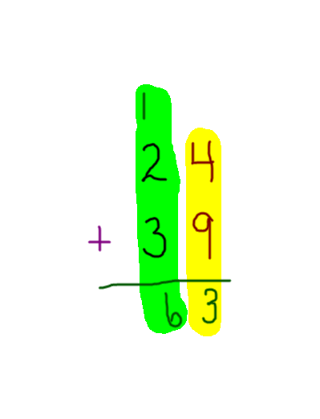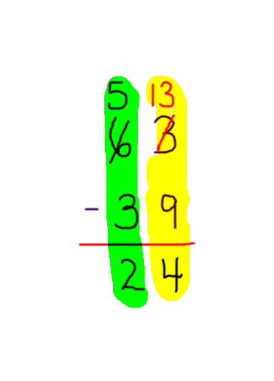

When multiplying whole numbers, students need to be able to use expanded notation to understand the algorithm for double digit multiplication. An algorithm is a method of computation. For example, 24 X 35 is really equal to 20 + 4 times 30 + 5. So, when multiplied out, the students would multiply each part.

20 X 30 = 600
20 X 5 = 100
30 X 4 = 120
5 X 4 = 20

All of these would then be added to equal the product, 840.
This method will help the students understand the process of computing when multiplying two digit numbers and should be demonstrated with base ten blocks.

Here is an example of the standard algorithm for multiplication of two digit numbers:

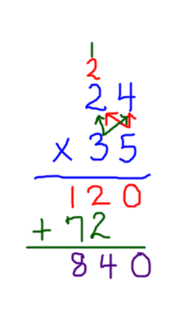
Take a moment to compare the partial products method with the standard algorithm above. Notice when students need to multiply and then add by looking at the color coding. Notice that when the three in the tens column is multiplied by the four in the ones column, the product is placed in the tens column. If the students work this problem in expanded notation as partial products first, they will understand why there is no digit in the ones column when multiplying by 30. Alternatively, a zero may be placed in the empty space in the ones column to show that the product in that row is a multiple of 10.

Another method for multiplying two digit numbers is lattice multiplication.

Here is an example:
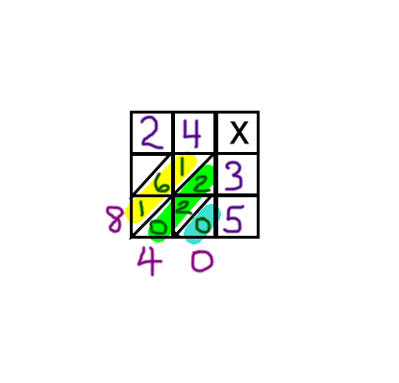
In the example above, the factors are written in the boxes across the top and down the right side. The operation is placed in the upper right corner. Diagonal lines are drawn to separate the ones and the tens in the product of each digit. The grid is filled in similar to a multiplication table grid with the diagonal lines to separate ones and tens. Tens digits are on top of the diagonal line and ones digits are under the diagonal line. These diagonal lines then serve to form new sections for the addition part of the problem. The blue highlighted area will be the answer for the ones column, the green highlighted area is the answer for the tens column and the yellow highlighted area is the answer for the hundreds column. If the column adds up to a number greater than ten, the ten is “carried” to the next diagonal column.

Notice and compare the three methods of double digit multiplication. Each one should be explained so that students have a full understanding of the methods used to multiply numbers.

Subtraction is the opposite of addition just like division is the opposite of multiplication. In this way, the subtraction methods can be used to introduce division. For example, since division is repeated subtraction, students can use repeated subtraction to divide. The standard algorithm for division is given in the example below:

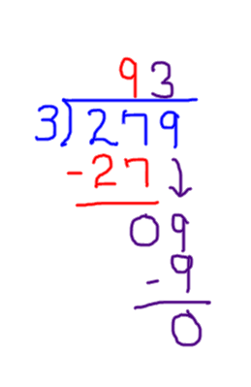

Notice that the order for long division is: divide, multiply, subtract, bring down. This continues until all the digits are used.

For calculations involving decimals, when adding and subtracting decimals, remember to line up the columns and keep the decimal between the same two columns.

For example:

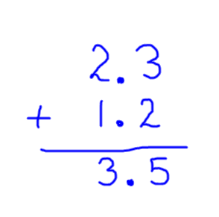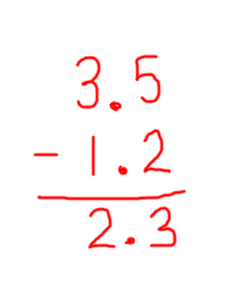

When multiplying by a decimal, the number of decimal places is equal to the number of decimal places combined, in both factors.

For example: 2.3 X 1.2 = 2.76. There was one decimal place in each of the factors, so there will be two decimal places in the product.

For division, if there is a decimal in the divisor, it is recommended that the decimal be moved over so that it is a whole number. Moving the decimal is allowable as long as it is moved over the same number of places in the divisor as it is in the dividend. After dividing, place the decimal in the quotient (answer) so that it represents the same place value as the dividend, so it should be directly over the decimal in the dividend. This is only possible if the divisor is a whole number.

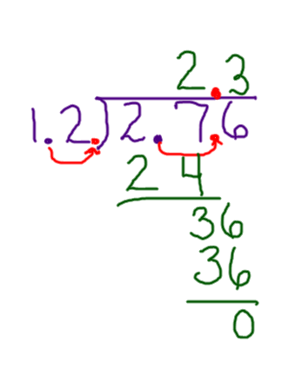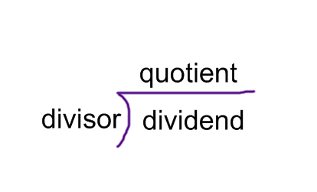

Here are three common definitions for fractions.
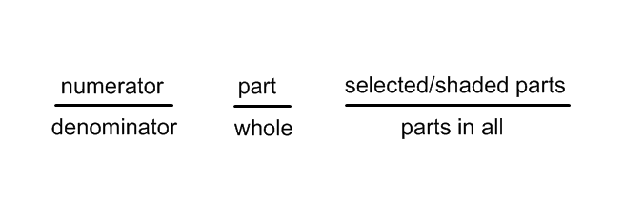
When adding fractions, one must have equivalent denominators.

For example, which of the following fraction sections could be added together easily?

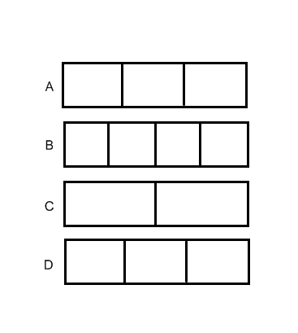
If you answered A and D you are correct because the sections are the same size. The key to adding and subtracting fractions is making sure that all the pieces to be added or subtracted are the same size. If they are not the same size, then we need to make them the same size before we add or subtract them. We can do this by using the concept of equivalent fractions to make them the same size.

In this example, all the pieces are the same size.

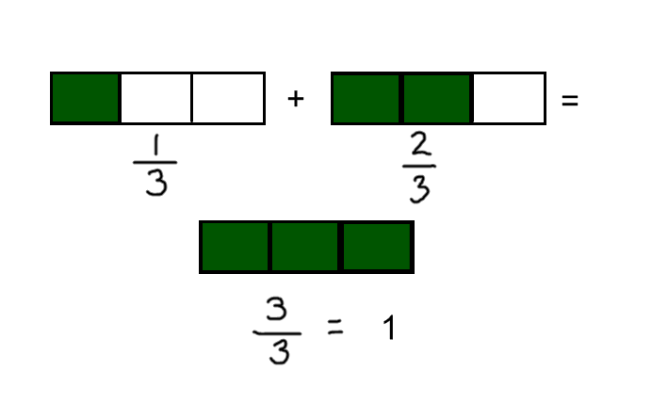
When all the pieces are the same size, the numerators are added or subtracted and the denominators stay the same.

In this example, the fractional pieces are not all the same size.

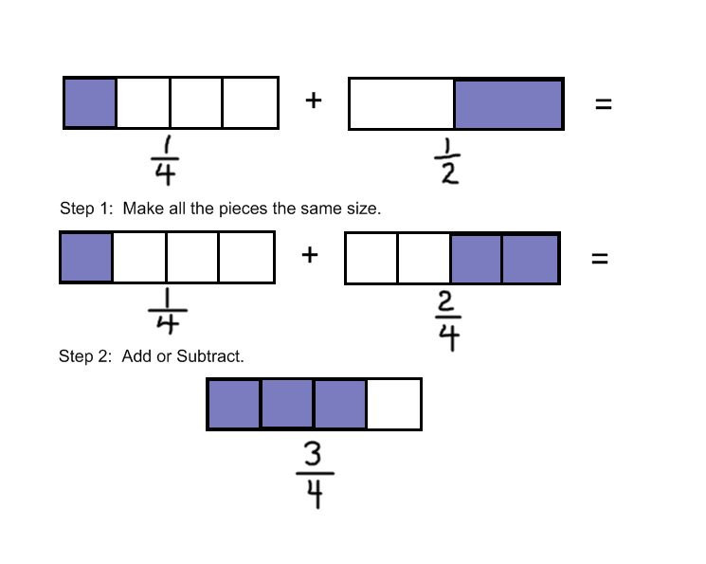
In this example, when the denominators are the same, the addition or subtraction happens in the numerator and the denominator stays the same.

For multiplication and division of fractions, the denominators do not have to be the same. For example:

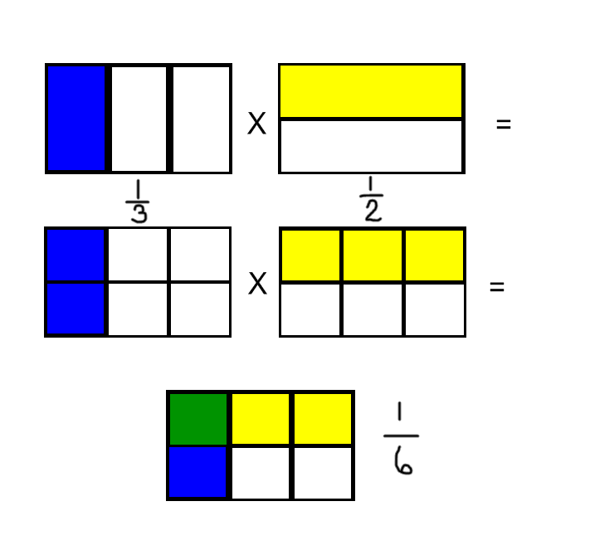
The above example is a visual of what is happening when fractions are multiplied. A number less than one is being multiplied by a number less than one. The result will be an even smaller number. The overlap of the yellow and the blue is the answer. The green square is where the yellow and blue overlap, so the answer is one out of six, or one sixth.
To multiply fractions, multiply the numerators and place that number in the numerator, then multiply the denominators and place that number in the denominator.

Here is an example involving the division of fractions.

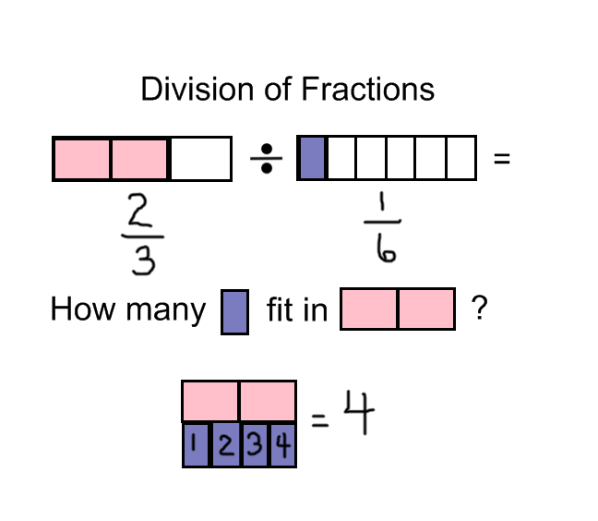
When dividing a fraction by a fraction, the number will usually increase. This is because the procedure involves counting the number of fractional pieces of the given fraction. The method involves inverting the second fraction and then following the rules for multiplication. Since multiplication and division are inverse operations, when dividing by a fraction one is really multiplying by the reciprocal of the fraction.

For example:
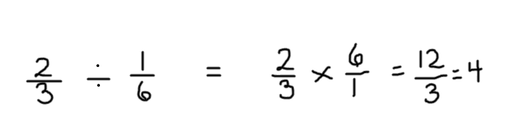

Objective 0014.7 focuses on applying methods for making estimations and for evaluating the accuracy of estimated solutions.

Rounding to the nearest 10, 100, or 1000 is done by examining the digit to the right of the 10, 100, or 1000. If the digit is 5 or more, the 10, 100, or 1000 digit increases by one. If the digit is 4 or less, the 10, 100 or 1000 digit stays the same and all the digits to the right of the given place value become zero.

Rounded numbers are easier to use when estimating solutions. Once rounded, they can be added, subtracted, multiplied or divided to give an approximation close to the exact answer. Estimation is useful in determining if any given solution is reasonable. Estimation is also a key skill in the development of number sense. Base ten blocks and number lines should be used to assist students in visualizing the process involved in rounding and estimating numbers.

Test Example –

Answer:

Vocabulary Words to Consider –

For Further Study –

Practice Questions –

0014.1

0014.2

0014.3

0014.4

0014.5

0014.6

Annotated Answers to Practice Questions –

0014.1

0014.2

0014.3

0014.4

0014.5

0014.6

0014.7

Objective 0015 Understand principles and skills of measurement and the concepts and properties of geometry.

For example:

Objective 0015.1 focuses on identifying appropriate measurement procedures, tools, and units (i.e., customary and metric) for problems involving length, perimeter, area, capacity, weight, time, and temperature.

What ideas come to mind when thinking about measurement? These are some of the vocabulary words associated with measurement. There are measurement tools, units, scales and concepts. In this section, we will categorize and make sense of all these concepts of measurement.

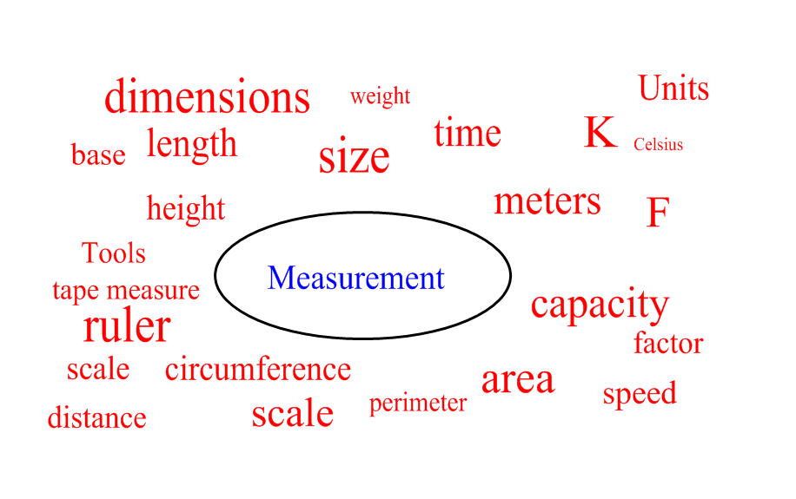

As students learn each measurement concept, they are also introduced to both customary and metric units. These units should be taught side by side. They measure the same concept, but use different units and different scales.

Measurement concepts begin with length, which measures the distance between two endpoints. Length is one dimensional.

Customary Units for Length: inch, foot, yard, mile

12 inches = 1 foot
3 feet = 1 yard
5280 feet = 1 mile

Metric Units for Length: millimeter, centimeter, decimeter, meter, decameter, kilometer

1000 millimeters = 1 meter
100 centimeters = 1 meter
10 decimeters = 1 meter
10 meters = 1 decameter
1000 meters = 1 kilometer

Notice that the customary units do not have a common anchor unit. The anchor or base unit by which all the other units are derived is the meter in the metric system. In the customary units, feet are defined in inches and miles are defined in feet.

Perimeter is the distance around a two dimensional figure, but is measured in length, a one dimensional unit. In order to calculate the distance around a rectangle, students should add both lengths and both widths to obtain the total. In order to calculate the area of a rectangle, the number of square units can be counted, or multiply the length X width.

For example,

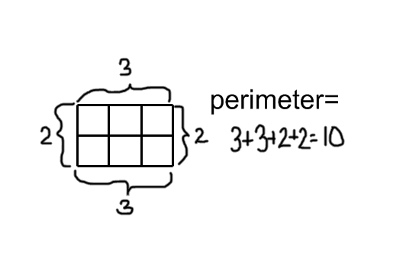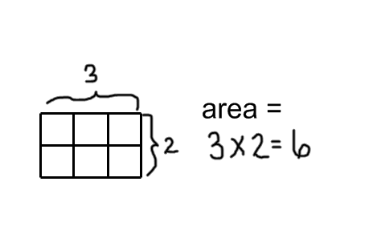

Capacity/Liquid Measure

Customary Units for Capacity

1 Gallon = 2 Half Gallons
1 Half Gallon = 2 Quarts
1 Quart = 2 Pints
1 Pint = 2 Cups

The liquid measure fractions model can be used to reinforce concepts of capacity involving customary measurement. The gallon contains all the related smaller units. They are embedded inside the gallon. This enables students to see the relationships among the units.

Metric Units for Capacity

1000 milliliters = 1 Liter

The liter unit in the metric system is derived from taking a decimeter and making it into a square with a length, width, and height of one decimeter. That square decimeter container is equivalent to one liter. In the same way, one cubic centimeter is equal to one milliliter, abbreviated mL. The ones unit in the standard base 10 blocks set, if empty, would hold exactly one milliliter of water. The thousand cube in the standard base 10 blocks set, if empty, would hold exactly one liter of water.
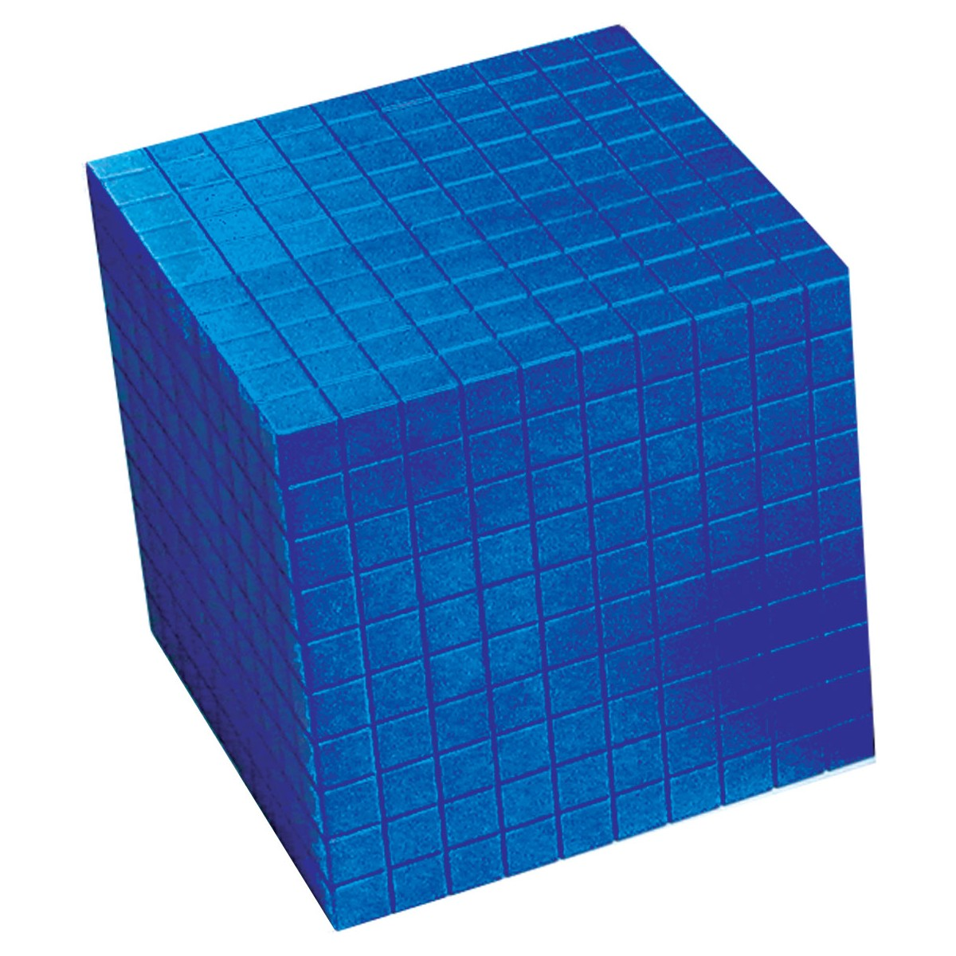

Citation for this image: http://www.learn-play.eu/product.php?id_product=223&id_lang=1

Customary Units for Weight
16 ounces = 1 pound
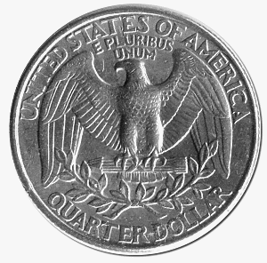
5 United States quarters weigh approximately one ounce.
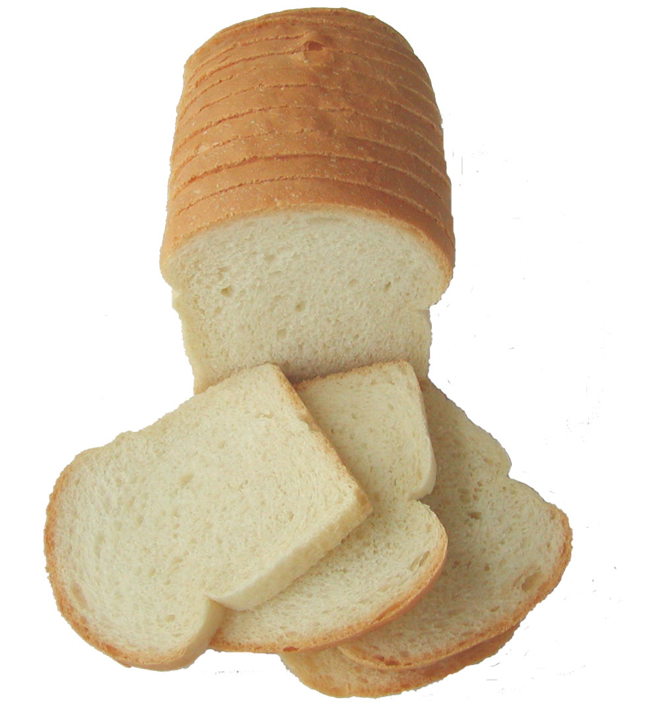
A loaf of bread weighs approximately one pound.
Citation for this image: http://www.mohrresults.com/nutrition/eat-more-white-carbs-lose-more-weight/

Weight is measured with a spring scale and depends on gravity to pull the object down.
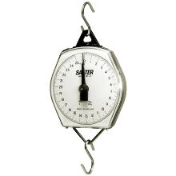
Citation for this image:
http://www.oakleyweigh.co.uk/catalog~guid~d8c9e55c-f666-48ca-a8ec-343aeb69b0b9.html

Metric Units for Mass
1000 grams = 1 Kilogram
One dollar bill weighs about one gram.
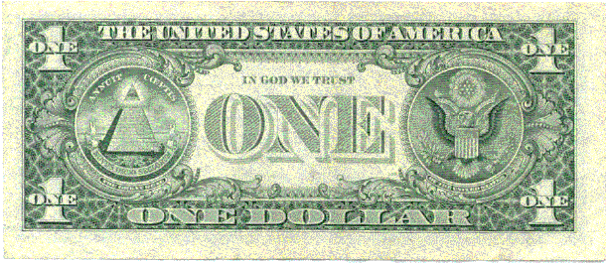

Mass is measured on a balance scale and does not depend on gravity because that same balance scale can be used in environments with different gravities and still function with the same results.
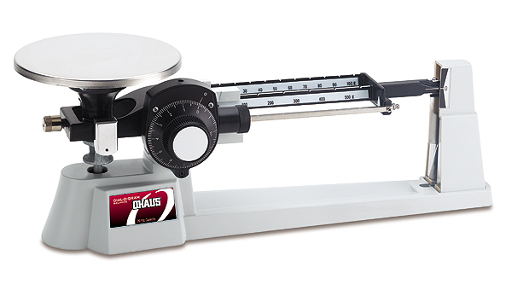
Citation for this image: http://www.lectronet.com/2011/04/07/balance-scale-2/

A kilogram would weigh about 2.2 pounds if measured on a spring scale on earth.

Time

When studying time and elapsed time, it is helpful to have visual aids that can be directly manipulated by the teacher such as a Judy Clock. Students should make their own clocks out of paper plates and paper fasteners as well. The Judy Clock is helpful when a teacher wants to show a particular time or show elapsed time because the gears in the background ensure that the minute hand and hour hand are always in sync.
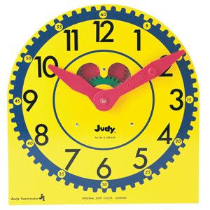

Citation for graphic http://www.learningthings.com/itemdesc.asp?ic=FSP0768223199
Temperature
Compare the boiling and freezing points of water for the Celsius and Fahrenheit temperature scales using the diagram below. Note that the temperature units are not the same size. Kelvin is another temperature scale. In Kelvin, water freezes at approximately 273 degrees. Zero in the Kelvin scale is considered “absolute zero.”
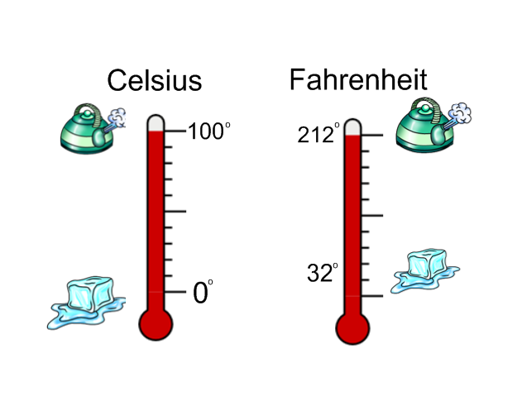

Objective 0015.2 focuses on applying knowledge of approaches to direct measurement through the use of standard and nonstandard units and indirect measurement through the use of algebra or geometry.

The standard units for measurement include both customary and metric units. The units described in objective 15.1 should be selected based on the attribute to be measured. Length is usually measured in inches or centimeters and area is usually measured in square centimeters or square inches. Volume is usually measured in cubic inches or cubic centimeters.

Non-standard units can be any number of objects with a consistent length or size. For example, paperclips or toothpicks can be laid end to end and used to measure length. A hand span or a footprint can also serve as nonstandard units. Students can measure distance by lining up their feet, end to end, and counting the number of “feet”. These are considered nonstandard units because the length of feet varies from person to person. Nonstandard units are a great way to introduce the concept of units and the need for consistency in units when measuring.

Objective 0015.3 focuses on classifying plane and solid geometric figures (e.g., triangle, quadrilateral, sphere, and cone).

Students learn about two dimensional (plane) and three dimensional (solid) figures.

Examples of two dimensional (plane) figures:
Triangle: Three sides
Students can use geoboards and rubber bands to create different kinds of triangles. Next, they can categorize the triangles that they have constructed into right (one 90 degree angle), acute (all interior angles are less than 90 degrees) or obtuse (one angle greater than 90 degrees) types of triangles. All the interior angles of a triangle add up to 180 degrees.
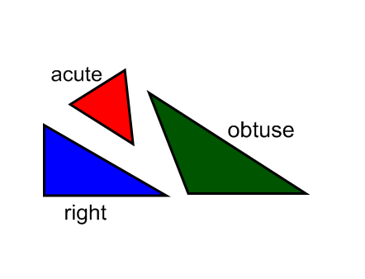

Quadrilateral: Four sides

Students can use Quadrilateral Pieces: A Geometry Puzzle to explore and create different types of quadrilaterals.

Quadrilaterals have exactly four sides. There are four quadrilaterals in a set of Quadrilateral Pieces.

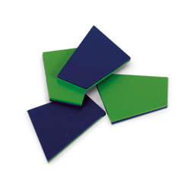
Trapezoids have exactly one pair of parallel sides.

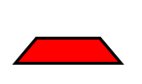

Parallelograms have two pairs of parallel sides.

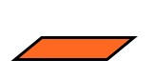

Rectangles have two pairs of parallel sides and all right angles.

A rhombus has all equivalent sides.

A square has all equivalent sides and all right angles.
Here is a graphic with several types of quadrilaterals.

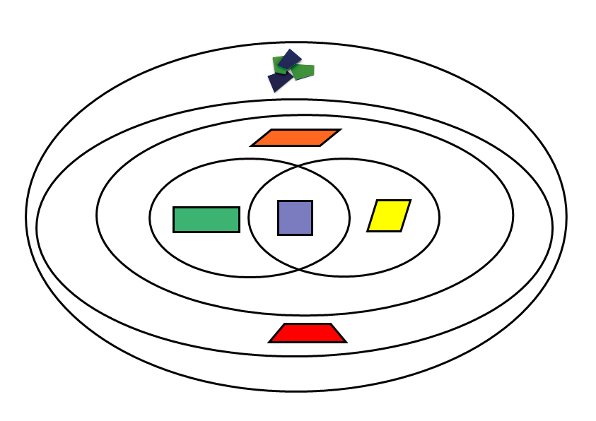
Note the intersection of the rectangle and the rhombus includes the square. Although the quadrilateral pieces are just quadrilaterals (four sided figures), they can be used to construct other specific types of quadrilaterals such as squares, rectangles, parallelograms and trapezoids. They can also be used to reinforce types of angles such as right, acute and obtuse angles as well as parallel and perpendicular lines.

Pentagon: Five sides
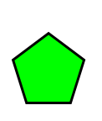
Hexagon: Six sides
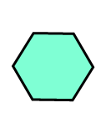
Solid figures include:

Cube: six faces
The three dimensional cube is shown and the “net” that can be used to construct it.
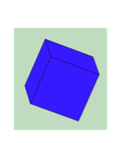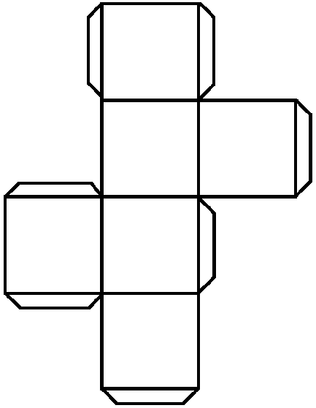
Tetrahedron: four triangular faces
The three dimensional tetrahedron is shown and the “net” that can be used to construct it.
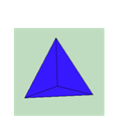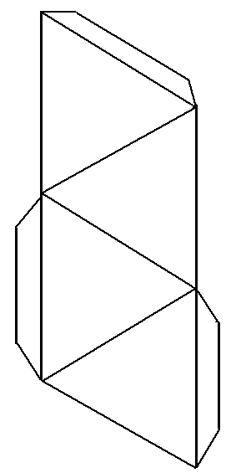

Dodecahedron: twelve pentagon faces
The dodecahedron is three dimensional. The “net” shown can be used to construct it.
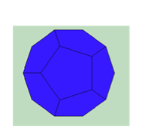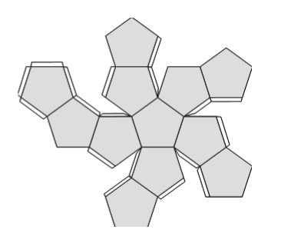

The National Council of Teachers of Mathematics has an applet for solid figures at the following site:
http://illuminations.nctm.org/ActivityDetail.aspx?ID=70

Objective 0015.4 focuses on applying knowledge of basic geometric concepts (e.g., similarity, congruence, and parallelism).

Similar figures are the same shape, but not necessarily the same size. All circles are similar to all other circles. Equilateral triangles are all similar to all other equilateral triangles.

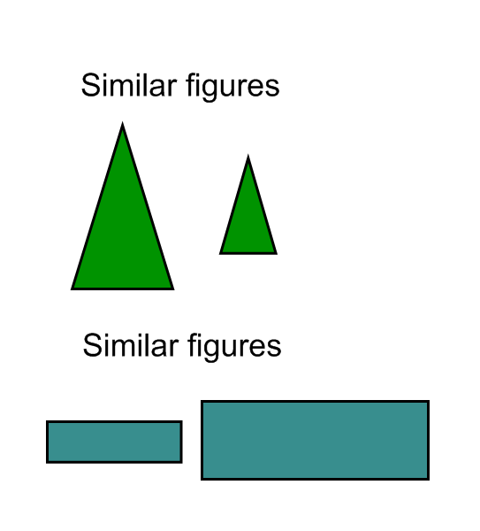
Congruent figures are exactly the same size and shape.

Parallel lines on the same plane never meet. Perpendicular lines meet at right angles.

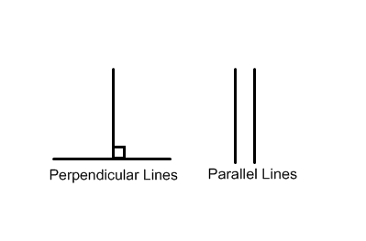

Objective 0015.5 focuses on applying strategies for measuring the component parts of geometric figures (e.g., angles, segments) and computing the volume of simple geometric solids.

There are three types of angles, right, acute and obtuse. They can all be indentified within the Quadrilateral Pieces.
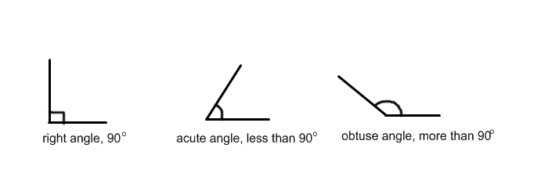
The volume of geometric solids is the number of cubic units within a given shape. Filling an empty solid with cubic units such as the ones from the base 10 blocks can serve as an illustration.

Volume is a measure of the area times the height. Multilink cubes can also be used to show how volume is calculated. The students should look at one corner of cube or rectangular prism. From that one corner, they can measure the three edges that come together to make that corner or vertex. One measure will be the length, one the width, and one the height. When length, width and height are all multiplied together, the volume is the product and the units are cubic units. Notice that each layer has 9 cubes, so 9 x 3 equals 27 cubes total. The units are cubes. For area, the units are squares. For volume, the units are cubes.
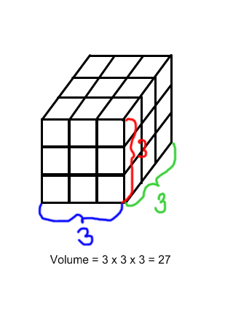

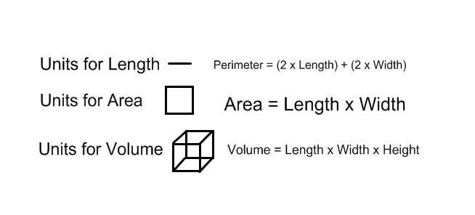
Objective 0015.6 focuses on applying knowledge of coordinate systems to identify representations of basic geometric figures and concepts.

The coordinate plane is constructed from the x-axis, the horizontal line, and the y-axis, the vertical line. The point where the x and y meet is labeled (0,0), commonly referred to as the origin. The X value in any coordinate pair (x,y) is the first value listed. If the x value is positive, it will be to the right of the origin. If the x value is negative, it will be to the left of the origin. The Y value in any coordinate pair (x,y) is the second value listed. If the y value is positive, it will be above the origin. If the y value is negative, it will be below the origin. In this way, there are 4 quadrants in the coordinate plane. The sign of the values (positive or negative) will determine the quadrant where the point is graphed. The points are graphed on the intersection of the gridlines.
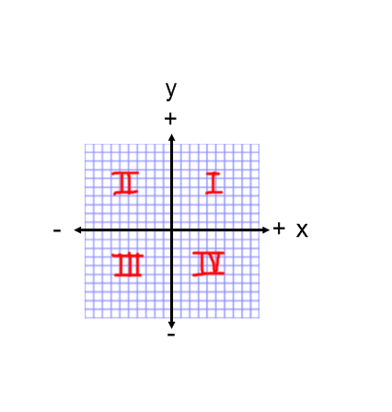

Objective 0015.7 focuses on demonstrating knowledge of applications of measurement and geometry in everyday life.

Geometry and measurement can be found in sports, nature, building. Any object that exists in space is geometric and can be measured. From baking to boating, every aspect of life includes these two subjects.

Students should be shown the applications to daily life. They should also develop the ability to look for geometric and measurement concepts of spatial awareness and quantity both inside and outside of the classroom.

Test Example –

Answer:

Vocabulary Words to Consider –

For Further Study –

Practice Questions –

0015.1

0015.2

0015.3

0015.4

0015.5

0015.6

0015.7

Annotated Answers to Practice Questions –

0015.1

0015.2

0015.3

0015.4

0015.5

0015.6

0015.7

Objective 0016 Understand concepts and skills related to algebra.

For example:

Objective 0016.1 focuses on recognizing the characteristics of patterns, identifying correct extensions of patterns, and recognizing relationships (e.g., color, shape, texture, number) among patterns.

Students can practice recognizing and creating patterns with manipulatives and items found at school or home.

Pattern blocks, attribute blocks, unifix cubes, or multi-link cubes can be sorted and classified by the students. The teacher can begin a pattern and ask the students to supply the next item in the sequence of patterns. Letters can be used to designate patterns such as ABABAB or AABAABAAB.

Collections brought in from home such as a matchbox car collection or collection of buttons or seashells make for wonderful patterns. Students can sort and classify the items using one, two, and then three circles as Venn Diagrams.
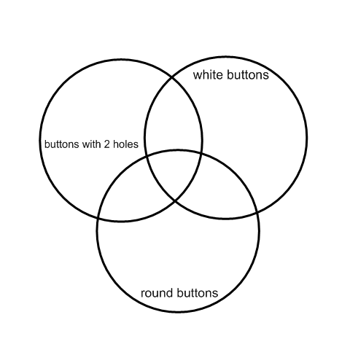

Objective 0016.2 focuses on applying knowledge of the concepts of variable, function, and equation to the expression of algebraic relationships.

A function machine can be used to identify the components of an algebraic expression. Look at the function machine. Try to determine the missing value.

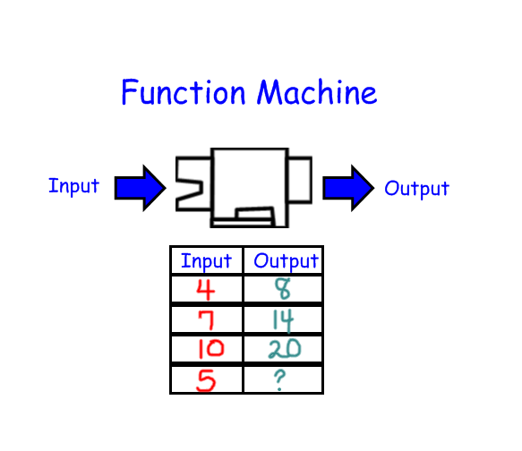
Notice that what goes into the machine is the input and what comes out is the output. In each case, the machine is doing the exact same thing to each input. In this case, each input is doubled. This would be written “input times 2,” or 2X with X as the variable.

The output is what is what results after the function machine does its work. Students try to figure out the function. If given the input and the function, they can fill in the output. If given the input and output, they can figure out the function. If given a few examples, they can supply the rest of the data.

Objective 0016.3 focuses on identifying relationships among variables based on mathematical expressions, tables, graphs, and rules.

Using the information below, try to figure out what is happening in the machine, the function. Next, calculate the missing output.
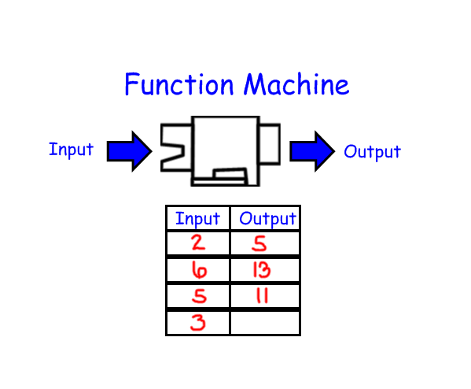
Notice that in each case the number is doubled and then one is added. The function is “double plus one,” or 2X + 1. When the function is applied to the input of 3, it is (3x2) + 1, which equals 7. Students can use their knowledge of even and odd or multiples to uncover the secret in the function machine.

In the example below, the function is given, but the missing values are in the input and output columns.
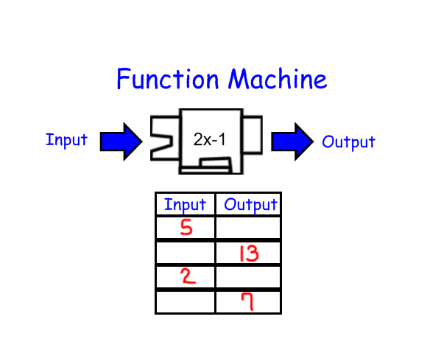
In this case, the 5 is put into the machine and comes out as 9. Two goes in and comes out as 3. How would one get an output of 13? Since the function took one away, to reverse the function, add one. (13 + 1 = 14) Since the function doubles the value, to reverse the function, divide by 2, (14 / 2 = 7). The original number for the output of 13 was 7. For the last row, the original value of seven was 4.

In the next example, the data is given in either column, the function is unknown.
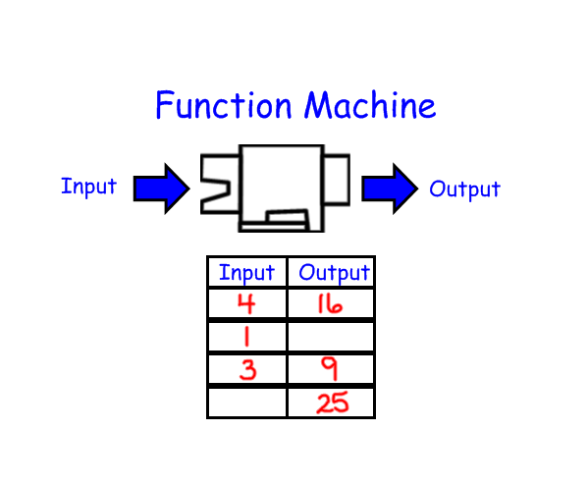
In the function above, the input is multiplied by the input to obtain the output. The numbers are squared. In the second row, 1 x 1 = 1. In the last row, 25 = 5 X 5.

Objective 0016.4 focuses on applying the methods of algebra to solve equations and inequalities.

When solving equations and inequalities, the goal is to isolate the variable. The variable can be an empty square or a letter such as x or y.

For example, if 4 is added to x to equal 9, 4 must be subtracted from both sides so that the variable, x, is isolated.
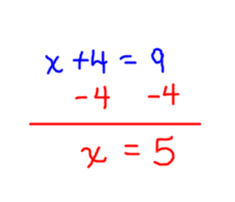
Since subtraction is the opposite or inverse of addition, when a number is subtracted from x, to eliminate it one must add that same number to each side of the equal sign. For example:
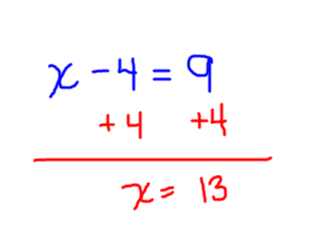

If an unknown is multiplied by a number, the number must be divided to isolate the variable. If the number is divided by a number, it must be multiplied to isolate the variable. For example:

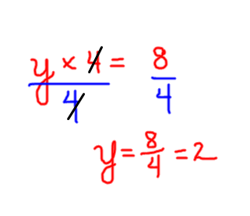
The inverse operation for multiplication is division. When dividing, multiply to isolate the variable. For example:

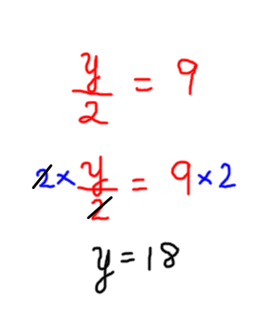
When inequalities are involved, recognize the meaning of the symbols for inequality.

Definitions:

A < B In this case, < means the first quantity (A) is less than the second quantity (B).

A > B In this case, > means the first quantity (A) is greater than the second quantity (B).

All operations for inequalities are the same as the operations for equalities as described above. The inequality sign stays the same for all basic operations. However, when multiplying each side by a negative number greater than or equal to one, the inequality sign will be reversed.
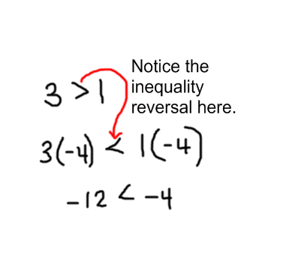

Objective 0016.5 focuses on analyzing how algebraic functions are used to plot points, describe graphs, and determine slope.

Notice the example below. The equation y=2x+1 is represented on the graph. The first step is to set up at “T-chart” as shown. For every value for x, a corresponding y value is calculated based on the equation. Several values for x are pre-selected and the corresponding value for y is calculated and placed in the T-chart. These ordered pairs are graphed as points on the coordinate plane. Next, a ray is drawn that serves to connect the points. All the points on the line are solutions to the given equation. Some are whole number solutions, some are not. There are an infinite number of solutions, so the ends of the ray show outward stretching arrows.
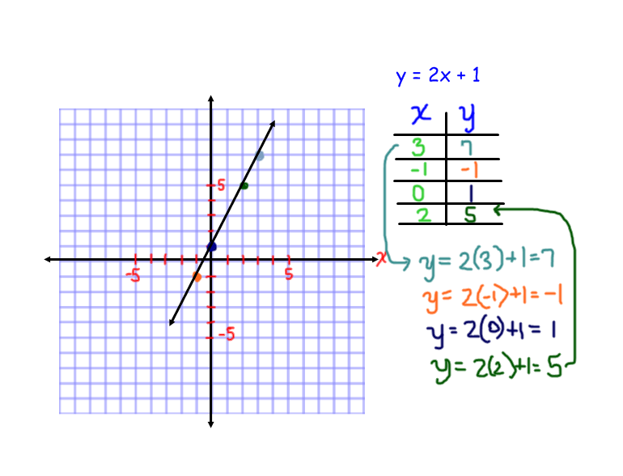

To determine slope, look at the number of spaces the points move up (y value) compared to the number of spaces the points move over (x value). This is commonly referred to as the “rise over run”. When operating with positive values, a greater the slope means a greater rate of incline. A hill with greater slope will be harder to climb. A hill with a smaller slope will be easier to climb. Here is the formula for calculating slope:

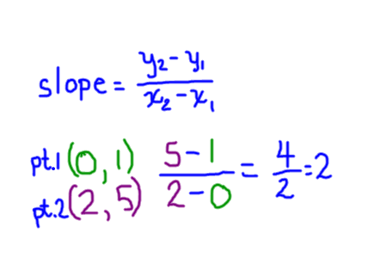
The two points, point 1 and 2, are derived from the T-chart. They are then filled in to the equation for calculating slope. The fraction is then simplified; the slope of the line in the example is equal to 2.
The slope can also be indentified when the equation is in the form: y=mx + b where b is the y intercept and m is the slope. Since our original equation was already in this form, we can see that the line crosses the y-axis at 1 and the slope is 2.

Objective 0016.6 focuses on demonstrating knowledge of applications of algebra in representing relationships and patterns in everyday life.

If you look closely, patterns and algebraic relationships can be seen in everyday life. We can see patterns in our heartbeat. Our heart rate and blood pressure can be measured and graphed. Speech recognition software makes use of algebra to detect sound patterns and transform them into written text.

Patterns in reproduction rates for rabbits and turtles, birds and fish are all based on algebra. As our brains seek symmetry and harmony, we enjoy the music that we hear in nature, all a symphony of repeating and varying patterns. Musicians use the patterns described in algebra to craft beautiful melodies. Architects use their knowledge of patterns to construct modern wonders of steel and wood.

Test Example –

Answer:

Vocabulary Words to Consider –

For Further Study –

Practice Questions –

0016.1

0016.2

0016.3

0016.4

0016.5

0016.6

Annotated Answers to Practice Questions –

0016.1

0016.2

0016.3

0016.4

0016.5

0016.6

Objective 0017 Understand concepts and skills related to data analysis.

For example:

Objective 0017.1 focuses on applying knowledge of methods for organizing and interpreting data in a variety of formats (e.g., tables, frequency distributions, line graphs, circle graphs).

The Pictograph

The first stages of graphing involve graphing with actual objects. Next, students begin to make representative graphs involving pictures. This is an example of a pictograph. It may come with a key that defines the amount represented by each “picture.” Pay close attention to the pictograph “key.” The key can change the meaning of the graph.
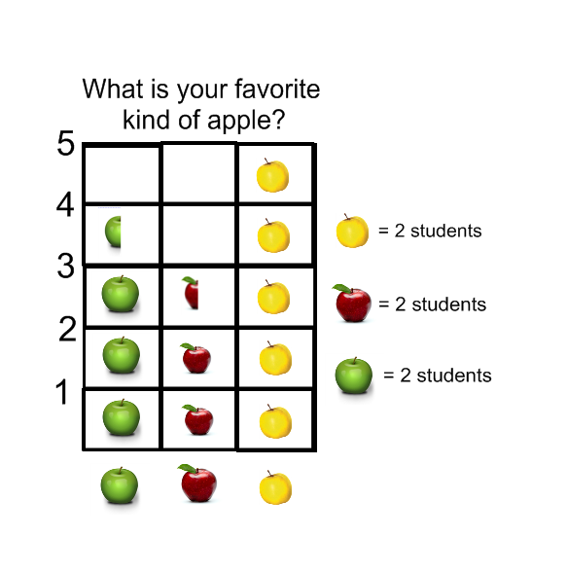
The Bar Graph
Creating a bar graph is the next step in learning about data analysis. Students can use post-it notes to create a bar graph as they stack the squares in the column chosen. This is an example of a bar graph that was created in Excel. Notice that it has a title and the x and y axes are labeled.

The line graph is set apart from all the other types of graphs because it is only used to represent changes over time. Data such as temperature or heart rate are appropriate applications for line graphs. Here is an example of a line graph that shows changes in temperature over time. Notice that the points are connected with lines. The points should only be connected with lines when the data is continuous or represents change over time.

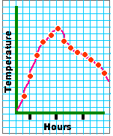
Citation for graphic http://www.designcoalition.org/kids/energyhouse/graphs/joined.GIF

Pie/ Circle Graphs

A pie or circle graph represents data in relation to the whole. This is an example of a circle graph that was created in Excel to show how the hours in a typical day may be spent.

The circle graph is useful for part to whole thinking concepts because the individual sections of data can be visualized in terms of the entire data set.

Objective 0017.2 focuses on identifying trends and patterns in data.

Students should be able to read each type of graph. Looking at the chart title, the data labels, and the data, students should be able to answer comparison based questions such as how many more students prefer yellow apples or what is the least popular fruit. In analyzing the information contained in graphs, students should be able to find data points on a line graph. When using bar graphs, students should be able to make comparisons among responses. Students should pay close attention to the “key” so that they can fully understand the data and use it effectively.

Students should participate in data collection and presentation. They should choose topics to address and design instruments to collect relevant data. Students should be able to tabulate data and create charts and graphs with accumulated data. They should also then be able to summarize the data and draw conclusions based on the information collected.

Objective 0017.3 focuses on demonstrating knowledge of standard measures (i.e., mean, median, mode, and range) used to describe data

The mean, median, mode and range are all measures of central tendency.

The most commonly used measure, the mean, is also referred to as the arithmetic average. To calculate the mean, add up all the numbers and divide the result by the number of numbers added.

The median is the middle number. To derive the median, simply put all the numbers in order from least to greatest and select the middle number. If there are two middle numbers, one may take the average or mean of those two numbers to obtain the median.

The mode is the most frequently occurring number. To derive the mode, select the number that occurs most often. If there are two numbers that both occur most frequently at the same rate, the data set is said to be bi-modal.

The range of any set of numbers is the difference between the highest number in the set (maximum value) and the lowest number (minimum value) in the set of numbers.

Objective 0017.4 focuses on drawing valid conclusions based on data.

Students learn to draw conclusions based on the data presented or obtained. For example, suppose that the speed of vehicles traveling through a school zone was tracked per vehicle. The speeds were 24, 26, 34, 30, 25, 25, 29, 22 and 28. The students could then analyze those speeds through measures of central tendency. Take a moment to use the measures described in objective 0017.3 to analyze the speeds of consecutive vehicles through a school zone before continuing to the next paragraph.

The first step would be to put the numbers in order from least to greatest:

22, 24, 25, 25, 26, 28, 29, 30, 34

The range of the numbers is the difference between 22 and 34, or 34-22 = 12.

The median, or middle number, would be 26 because there are four numbers less than 26 and four numbers more than 26.

The arithmetic mean or average would be the sum of all the numbers divided by 9, the number of numbers. In this case, the mean would be 27.

The students could also wonder about what they think the speed limit was for the school zone. They could use the data to wonder about why one person was traveling 34 miles per hour. Could it be that they wanted to get somewhere in a hurry but knew that the police might issue a speeding ticket if they were traveling 10 or more miles over the speed limit? They might suppose that the speed limit was 25 because the average speed was 27 miles per hour and the median speed was 26. As they discuss their data and their conclusions, students could use their knowledge of measures of central tendency to try to interpret possible scenarios.

Objective 0017.5 focuses on demonstrating knowledge of applications of data analysis in everyday life.

Test Example –

Answer:

Vocabulary Words to Consider –

For Further Study –

Practice Questions –

0017.1

0017.2

0017.3

0017.4

0017.5

Annotated Answers to Practice Questions –

0017.1

0017.2

0017.3

0017.4

0017.5

